Assessment #1

Step 1: Introduction and Chapter 1 Reflection

After I have a head started reading about the introductions and chapters given. I just feel like I'm reading some boring but seems to be an amazing novel, I reckon. Since young, reading is not my thing. I would say, from these "novel" I found something quite interesting. Because I'm not like reading some text from the textbook, word flying around, scrabble up. Yet, I manage to finish reading two chapters, for now, of course. From this, I learn that interact with humans is important. I clam myself as a bit of an anti-social kind (although everyone doesn't think I am) for this unit, or even most of them. Discuss between peers is a good start and be able to understand more about every individual's thinking.

Peerwise, just like playing a game, that what I was told. Keep getting point and score higher point. I love for sure. If you want to win, you must try hard and FAST. Just like playing DOTA, or even League of legend. You need to know the skill, strategy, and trick to win the game. Answering questions about something that I learn make me feel like my hard work paid off from studying.

For me, getting a blog is kind of like showing the inner side of yourself. You type what you feel; what you did; and what you think. People will consistently check on what are you up to these days. From my aspect, writing on a blog is like sharing your happiness to people. For example. You bake a beautiful fluffy cake. You would love to share with people and getting feedback.

From reading chapter 1, I found it interesting because the previous workplace I worked it, they used Xero. At first, I thought I was just like an app for us to know our roster, hours we did and a tool for the business to pay the employee. It appears that through this software, it helps the employee to be able to do the accounting job easily online or we could say, through cloud-based accounting software.

From the paragraph of what is business all about, make me thinks of the hospitality industry. As a chef, we always must create beautiful food, just like accounting. Creating value in accounting is different but some objective. We also have to care what's the customer needs. As for our job, adapt, modify, develop and making changes consistently for people is the main purpose of doing the job.
To be honest, I don’t really like numbers. Since I was young, I got anxious whenever I got interact with numbers, but now hear, reading, studying, writing something that much related to numbers and probably all bout numbers?! Is accounting all about numbers? Or I can get more and learn more out of it. I looking forward to getting to know more about it.
From my experience, I pass thought a lot of sole traders. I have quite an amount of friend back home did their own business either online or open their own business. Some of them open their own café, some doing online selling, selling Cakes, and open a milk tea store. One day, I will do something different from them I promise. There are a few places I worked at is a corporation. Such as w hotel. They are a worldwide hotel that owns by a few shareholders. Each branch has its owner and director. But at the end of the day, they have a headquarter somewhere around the world. In my opinion, partnership one of the best types of business to operate, not much paperwork to be done, shared asset and liability. From what the idiom said, to enjoy blessing and endure misfortune together. Now, I have a question, what if one of the runaways? Is that mean the other owner has to cover all the loss?

I remember back in high school. I was major in accounting. In my memory, accounting is all about numbers, credit, debit, getting numbers together, getting number tally in each calculation. Unfortunately, I never get any calculation right!! And of course, I get a bad score on my final exam. At least I get a pass, if not I will get in big trouble with my parents (“Asian parent”)
Thanks to technology, now we have mostly everything been done and automatically calculated by the computer. This will help minimize human error as much as possible.

In conclusion, I’m looking forward to continuing reading this cool “novel”, try to love study, love numbers. After reading this chapter, I beginning to have some insight into accounting.
I’m confident that I will get the most out of this unit.

STEP 2
Moodle Profile: Click here
Blog Profile: Click here

STEP 3
I can’t wait to start talking about this company I got!

RWE, (Rheinisch-Westfälisches Elektrizitätswerk AG) a utility company I get for the assignment. It is a utility company. The second-largest company in Europe. They are a company that does quite a huge range of utilities. They did, energy, renewable energy power station, natural gas and oil, mines coal, delivers and distributes gas, and supplies drinking water. Before I start with their amazing work, lets throwback to their history. RWE has a roughly 120 years history. On about the year 1900, they are a small business that supplies only electricity to a small city named Essen. After two years, RWE’s electricity business getting better each year. Their mission is always providing low-cost electricity to the factories and household. Even it is a low cost of electricity, they still perform a high-quality service to their customer. This strategy allows makes them successful on the utility company. After a few years later, they develop and expand to the next stage where mining, wind-force energy comes to action.

They are really “a pain in the backside”. Because they are a big company, in another word, RWE has a lot of different occasion happening. While I was doing my company spreadsheet. Wait. First. I read through their recent annual report (2018) they seem to be a very normal company to me since they are doing just utilities. I thought it would be like Origin, AGL, red energy or something similar. But I was WRONG. RWE even have coal mining. RWE and E.on were joint since 2009 for their Horizon nuclear power.

From the research I did, total revenue RWE obtains in 2016 was €33.397. but when it comes to 2017, their income statement shows that there’s only €13,833. That -68.29% different from the previous year (€43590). So, after that, I dig into their article and news from the internet. It says that RWE face a huge drop in revenue due to shut down of nuclear power station in Gundremmingen B. It forced to shut down permanently on 31 December 2017. I’m all over this company's spreadsheet. Every single item from the financial statement is so different from what lecturer show us. For my income statement, the amount for income needs to be added in from statement of comprehensive income.

This should be one of the reasons why their statement was so different from the previous. How can that even be happening for such a big company? I never expected that a big company would be closing down station due to the sustainability problem.
Continue with my research. RWE’s income was slowly increasing from 2018. They know how to make full use of their asset. For example, their children company, E.on. they change the operating structure. Both RWE and E.on will supply different types of energy rather than the same resource from both companies.

Today while we are in lecturer class, all my question pretty much got solve, our tutor, Lois, she helped us a lot. She showed me how to get all the numbers tally, and how to fill in my company spreadsheet from all the financial statement given.
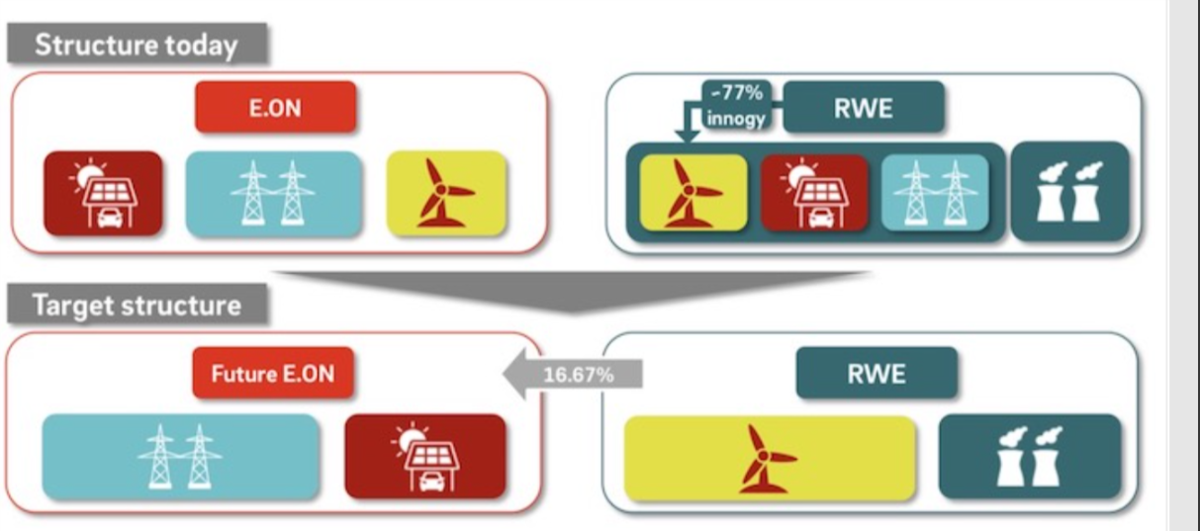
As the second-largest utility company of Germany, it is easier for them to get an important role after restructuring because they have on and offshore wind. That enables them to gain more energy by the transition. In this case. They will save more and receive more energy.

To conclude RWE’s statement for these few years (2016,2017,2018)
RWE AG total assets from 2016 to 2018
- 2018: €94.608B, 21.2% increase from 2017.
- 2017: €78.057B, 7.68% decline from 2016.
- 2016: €84.546B, 4.03% decline from 2015.
(https://www.macrotrends.net/stocks/charts/RWEOY/rwe-ag/total-assets)
RWE AG total liabilities from 2006 to 2019.
- 2018: €77.77B, 20.57% increase from 2017.
- 2017: €64.504B, 14.8% decline from 2016.
- 2016: €75.705B, 3.21% decline from 2015.
(https://www.macrotrends.net/stocks/charts/RWEOY/rwe-ag/total-liabilities)
RWE AG annual/quarterly revenue history and growth rate from 2016 to 2018

- 2018: €15.811B, 67.03% decline from 2017.
- 2017: €47.963B, 0.57% decline from 2016.
- 2016: €48.237B, 6.29% decline from 2015.

( https://www.macrotrends.net/stocks/charts/RWEOY/rwe-ag/revenue)

After I go through all my reports, the next step is to "spy on someone's company". I was expecting my other classmate have the same issue as mine, but apparently, they got some easier company with a smaller amount in their financial statement. (from my point of view)
I’m pretty sure everyone will face some similar but different problem.

One of my peers (Chloe) has a sportswear company retail from china named Pou Sheng (international). From her description, Pou sheng (international) growing rapidly and making a profit from exporting their product to other countries.

Another one (Amber), she got a gaming company, that’s what I want to get! I candy, a company which is one of the companies under Alibaba’s. How awesome is that? I candy is a company that incorporated in Melbourne Australia as a public company. And they even make their own game.

*BALANCE SHEET EQUATION USED: ASSET=LIABILITY + EQUITY. TOTAL ASSET METHOD. *

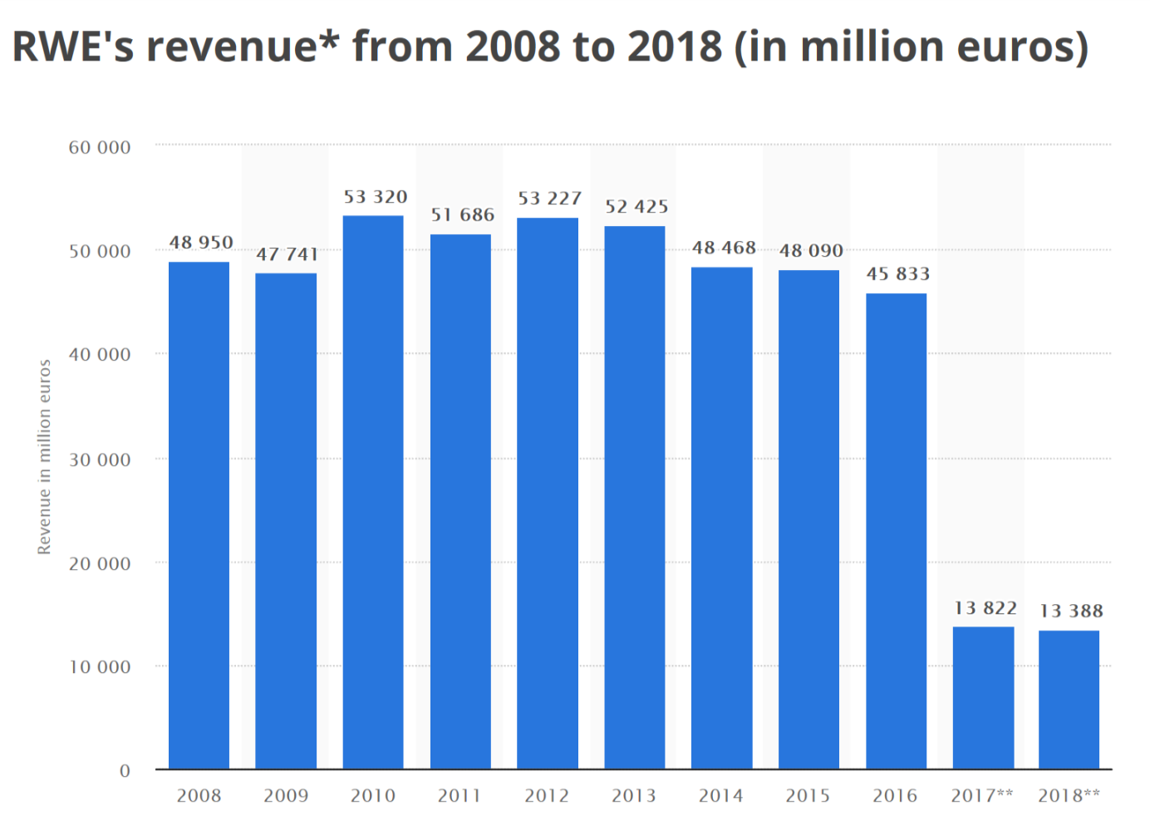

There are 3 bloggers I found interesting.
A blog from Chloe Reid.
https://chlodanielle.home.blog/
Her blog is full of information about her company. She did a lot of research and express a lot about her feeling toward her company( pou sheng). She one of my peers in class. She did a good job on her blog and also have a organize blog.

The second winner goes to Jessica Bishop
https://jess682167292.wordpress.com/
What a colorful and a blog full of pictures. I like to see blogs with excitement. She used a lot of her own words which tell people how exciting she is by typing it into words.

And the third goes to Sarah Jones
https://sarahaccountingblog.home.blog/
Sarah explains some key point of her company on her blog. Her draft was posted on her blog and while reading, I realized that she has a put her best effort on updating her blog.

I should learn more about blogging with some professional like them. Interesting work.

Step 4
I have attached my Company spreadsheet on my blog. Kindly find the attachment on there

Step 5

KCQ for Martin’s novel round 2.
How should I start? This is always the toughest question. Start reading and just writing a note while reading, or just read and write after everything. Then, I choose the choice to read and write.
On chapter 2, I feel like accounting is all about how to handle and master the game called “Accounting”. While reading, I come across the word “IFRS” standard. What is that? In my company’s changes in equity sheet, I saw this word on the 2018 statement. And yet, I got a result for this standard. IFRS is a standard to help businesses to show how a business did their accounting statement be done. This standard applied for almost all the country and it is created to standardize the accounting standard. Continue with my reading, the accrual accounting. I'm quite interested in this accounting because I never thought that kind of accounting, kind of like debt your money into somewhere to keep it for later use. If I didn't interpret it wrongly. Before this, I thought if you top up your transport card with money is just a debt account. now I know, is accrual accounting. INTERESTING. I agree with the author where he said: "accounting is a game". To me, accounting is definitely a game. It can determine whether you win or lose when you start to go into in, doing statement and provide correct information to get points. When I was doing my company spreadsheet for my assigned company, our lecturer shows me how to insert the formula into the column, this makes me think that I'm playing some plus-minus game. And when I get on the trick of doing it. I was so excited about doing the rest.
Continue with my reading, in chapter 3, I start to know more detail about my company financial statement. From the reading, I know that the statement that I insert now all make sense. I never know that there’s a difference between a parent and a group company. If there is a parent company, then what about children company? yet, I need to move on with my reading, 5 key elements that were been mention for a few times, asset, expenses equity revenue, and liabilities. These elements are really important in accounting.
And of course. Money is very important. From the saying "Cash is the boss". A good company will have positive cash flow, whereas if a company is not receiving any cash, something going on with this company, there's are two different types of cash flow, each of them has a different definition of cash flow. Normal cash flow is just cash that you received while selling goods or product, and free cash flow can be referred to as money that you spend to increase or upgrade your company. in other word, spending money. This doesn't mean you lose money, is just another form of cash flow.
Conclusion for this chapters of reading, get to know some terms and on how to read a financial statement is a key to finish this assignment. Although I don't fully understand the chapters, I manage to find the key point that I think is important to me for getting know about accounting at this stage.

Step 6
PEER FEEDBACK SHEET: ASS#1
https://nikole.video.blog/2019/08/02/draft/
Feedback From: WenJun Tan
Feedback To: Joella Nikole G. Birung.

 | My Comments
Step 1  KCQs | I like how you expressed your thought on how you like numbers. And also, on how you understand the key concept of what martin is trying to express
Step 2 | Apparently, I can’t excess to your Moodle profile. But from the small picture from the icon. You have a nice profile picture
Introductory words in Description box
Photo and description
Link to your blog/Set up blog
Step 3 | Keep up on your step 3 , looking forward to knowing more about your company
Background information on the company
Comments/KCQs
Comments on other’s blogs
Step 4 | Well done on the formula that you insert on your company spreadsheet
Input company’s financial statements

Overall ASS#1 | Enjoyed reading your step 1 but hope to read more of your work soon. cheers

PEER FEEDBACK SHEET: ASS#1
https://emilysdiary.news.blog/2019/07/24/assessment-1-step-3/

Feedback From: WenJun Tan
Feedback To: Emily Mark-Hudson .

 | My Comments
Step 1  KCQs | Enjoyed reading your step one and how you express your feeling through ward martin's writing. I feel that too.
Step 2 | It looks like you haven’t put any profile picture on your Moodle.  I can't go into your Moodle profile, but make sure you did your description through setting to get that extra mark.
Introductory words in Description box
Photo and description
Link to your blog/Set up blog
Step 3 | Good to hear that your company get profit throughout the years because I heard a few sad cases that companies that don't get any profit and keep losing.  It would be nice if it is in Microsoft word format.
Background information on the company
Comments/KCQs
Comments on other’s blogs
Overall ASS#1 | Nice work. Looking forward to more updates

PEER FEEDBACK SHEET: ASS#1
https://shannonbusbysblog.home.blog/blog-feed/

Feedback From: Wen Jun Tan
Feedback To: Shannon Busby .

 | My Comments
Step 3 | Good job on the referencing from your company provided. I saw that you really put a lot of effort in and straight to the point.  You did it in a clear way where everything is in section and is easier for the reader to read.
Background information on company
Comments/KCQs
Comments on other’s blogs
Step 4 | All statement is in but it would be better if you insert some formula from excel. The tutorial can be found in the Moodle site.
Input company’s financial statements

Step 5 | It would be better if there is more KCQ on step 5.
KCQs | It would be better if there is more KCQ on step 5.
Overall ASS#1 | Good to read your assignment. Organize but still, need some changes at some point.

